|  |  |  |
| --- | --- | --- |
| PERSONAL DETAILS **Date of birth:** 12th August 2000  **Residential Area:**  2441 Monwabisi Khayelitsha, Cape town  **Languages:** English, IsiXhosa EDUCATION 2019: Sinethemba Public School-Matric ONLINE PRESENCE **LinkedIn:**  [linkedin.com/in/ayabulela-mbodla-1756781b8](https://www.linkedin.com/in/ayabulela-mbodla-1756781b8)  **Email:**  [Ayabulelambodla230@gmail.com](mailto:Ayabulelambodla230@gmail.com)  **Contact number:**  0695288400 KEY SKILLS  * Data Capturing * Fast typing skills * Microsoft office * HTML, CSS, JavaScript and Python.  INTERESTS & HOBBIES  * Travelling * Listening to Music * Cooking * Hiking |  | ABOUT ME I am an ambitious and driven person. I thrive on challenge and constantly set goals for myself, so I have something to strive towards. I’m not comfortable with settling and I’m always looking for an opportunity to do better, improve myself and grow in the process. Connecting with individuals and creating a high- performance culture is a priority. I use innovation and lateral thinking to meet company’s needs. I have a collaborative style and as such I work well with teams. ACHIEVEMENTS & KEY PROJECTS  * Class representative in High School. * 100% attendance at CapaCiTi * 2019 Highflyer at FORT HARE  WORK EXPERIENCE **Company Name:** CapaCiTi Tech Career Accelerator  **Job Title:** Data Administrator Trainee  November 2020- 04 March 2021   * Working with Office equipment. * Computer Hardware and Peripheral devices * Microsoft Office * Retrieve data from data base or electronic files as requested and update existing data.   **Company Name:** CPGR  April 2021 – September 2021  **Job Title:** Data Administrator.   * Reception duties (ADHOC) * Filing calibration/service reports and updating QMS reports * Providing administrative support to the procurement department. * Equipment and environment temperature monitoring. * Aid with relocation plans and packing.   **Company Name:** CapaCiTi Tech Career Accelerator.  October 2021 – Current  **Job Title:** Systems Development   * HTML, CSS, JavaScript |

# **TECHNICAL DEVELOPMENT**

Technical Skills and modules covered over the duration of the programme

| **Technical Skills and Projects** | **Modules Artefacts** |
| --- | --- |
| * Basic End User Computer. * Microsoft Office suite. * Data & Accuracy. * Microsoft Office Practical. * Internet Proficiency. * Trouble Shooting. * Computer Shortcuts, Tips & Tricks. * Computer Security & Confidentiality. * Data Labelling, Types & Tables. * Data Capturing. * Transferring Data from paper to Electronics. * Create & Setup regular data backups. | * Basic End User Computer Assessment. * Microsoft Office suite project. * Payroll & Call Statistics practical. * Google Survey. * Microsoft Office. * Trouble Shooting. * Database Compiling. * Data Transferring. * Data Management. |

MENTOR TESTIMONIAL

Ayabulela is a young woman who has worked hard at producing great sets of technical work on time. She has grown to be a pleasant and competent person who does her best to help others where she can. Technically her competence has grown in the MS Office Suite as well as typing. She is a very talented individual with a passion for learning new things. Ayabulela has also done amazing work on team projects.

PROGRAM DATA

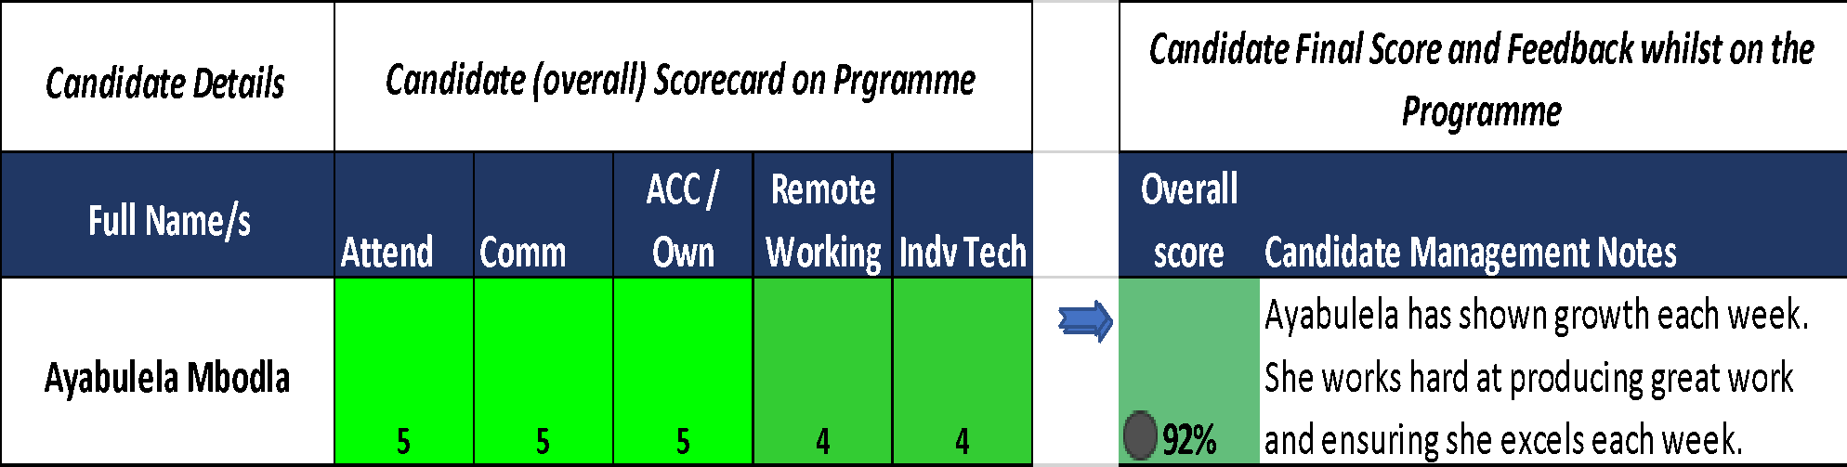

# **PROFESSIONAL DEVELOPMENT**

CapaCiTi Job Critical Skills covered over the duration of the programme

| **Competency: Communication**  Modules   * Principles of effective verbal communication and body language * Principles of structuring and presenting information * How to listen and why it matters * Feedback: To and from | Outcome   * Aware of how to communicate impactfully * Effective presentation skills * Able to actively listen and paraphrase * Giving and receiving feedback effectively |
| --- | --- |
| **Competency: Goal Setting**  Modules   * Goal setting * Decision making * Career path mapping | Outcome   * Able to use goal setting and tracking methodology * Equipped with tools for guiding choices * See connection between course material and future goals |
| **Competency: Work Ready**  Modules   * Scorecard and Performance Management * Remote working | Outcome   * Experience of public accountability for performance * Managing working online and making use of remote tools |
| **Competency: Work Ready**  Modules   * Self-reflecting audit of strengths and weaknesses * EQ and Self-Control * Johari’s Window * Conflict Management * SWOT Analysis | Outcome   * Aware of development areas and strengths to build on * Aware of one’s own inner state * Self-awareness and development through feedback * Resolving Team Conflict - building stronger teams by facing your differences * Conducting a SWOT analysis at key points of program, focusing on areas of improvement and strengths to harness, including a SWOT Analysis of their remote working experience. |
| **Competency: Interview Fit**  Modules   * Introduction to Interviews - highlight purpose, misconceptions and fears * Job search and networking skills * Interview practice / role plays * Your professional brand | Outcome   * Experience in interview realities * Conducting own job searches * More confident managing stressors and interview questions * The importance of building a well curated online presence |

CANDIDATE MANAGEMENT TESTIMONIAL

Ayabulela is an extremely strong candidate and has great communication skills. She is hard working and able to work under pressure. She has grown since her time on the programme. She works well in a team; she is a very strong candidate that can stand her ground even in uncomfortable situations. Ayabulela has really shown her growth in her professionalism since being on the programme.